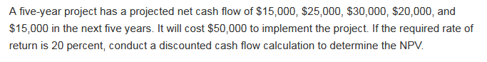

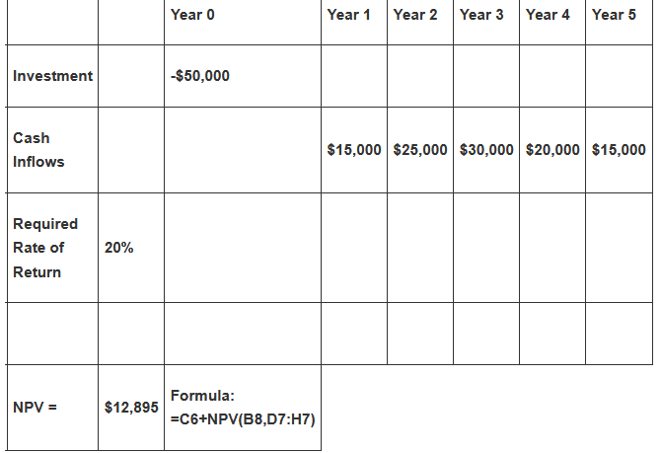

Since NPV is positive, the project should be accepted.